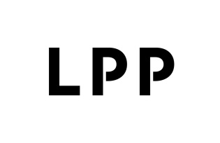

Share capital increase within the authorised capital
Current report no: 26/2022
Date: 01.07.2022
Time: 3:17 p.m.

The Management Board of LPP SA (the 'Company') announces that by the decision of 23.06.2022. District Court Gdańsk-Północ in Gdańsk, 7th Commercial Division of the National Court Register (ref. no GD.VII NS-Rej. KRS/010447/22/510), by virtue of resolutions of the Company's Management Board of 12.05.2022, amended the entry in the National Court Register concerning the share capital increase of LPP SA from PLN 3,704,846 by PLN 3,636, to PLN 3,708,482 and the relevant amendment to the Articles of Association of LPP SA (Article 5.1 and 2). The share capital was increased through the issue of 1,818 ordinary series M bearer shares with a nominal value of PLN 2 each.
At the same time, the Company's Management Board recalls that the resolution on authorising the Management Board to increase the Company's share capital within the authorised capital and to amend the Articles of Association of LPP SA accordingly was adopted by the Annual General Meeting of the Company on 29.06.2021. (current report no 18/2021), and the relevant amendment was entered into the National Court Register by a decision of the District Court Gdańsk-Północ, 7th Commercial Division of the National Court Register dated 31.08.2021 (ref. no VII NS-Rej. KRS/15420/21/413).
The content of the resolutions of the Management Board concerning the issue of shares under the authorised share capital increase and the amendment to the Articles of Association of LPP adopted by the Management Board on 12 May 2022 is provided in the appendix.

Article 56(1)(2) of the Act on Offering – current and periodic information

Signatures: Sławomir Łoboda – Vice President of the Management Board
Jacek Kujawa – Vice President of the Management Board

